Overview : The Theory of Machines course for Mechanical Engineering provides a comprehensive underst
and analysis of mechanisms for the specified type of motion in a machine. With the study of rigid bodies motions and forces for the transmission systems, machine kinematics and dynamics can be well understood.
In the lab, students typically have access to a variety of equipment and experimental setups that allow them to observe and manipulate different types of machines and mechanisms. This includes mechanisms like linkages, gears, cams, belts, and pulleys, among others.

Facilities and Equipment: Whirling of shaft + Motorized cam analysis, Universal governor, Motorized Gyroscope, Brake lining/ clutch friction test rig, Balancing of reciprocating masses , Universal vibration test rig, Generation of Involute gear-tooth profile model, Epicyclic Gear Train equipment, Cam Analysis equipment, Test rig for Belt Drive Equipment

Utilization: This course is for students from S.Y, T.Y Mechanical engineering and S.Y Manufacturing Engineering
S.Y Mechanical Engineering – 8 batches (25 students in each batch)
T.Y Mechanical Engineering – 8 batches (25 students in each batch)
S.Y Manufacturing Engineering – 4 batches (25 students in each batch)

Lab Incharge: Dr. Shivnanda Bhavikatti

Laboratory Area: 92 m²

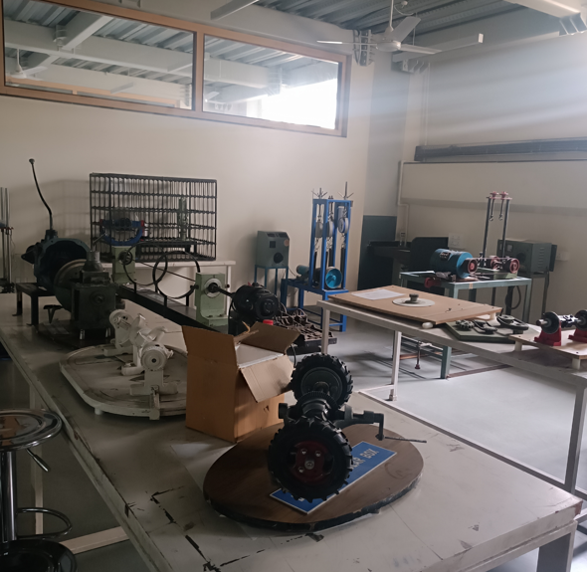

THEORY OF MACHINE :

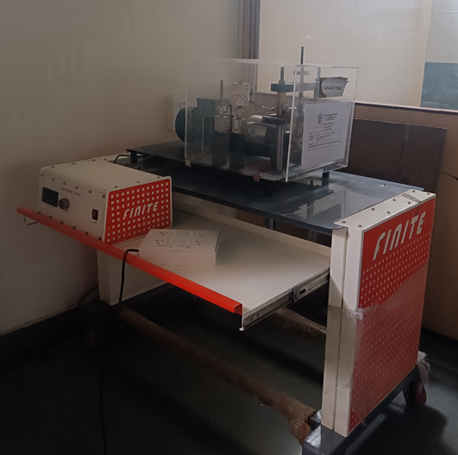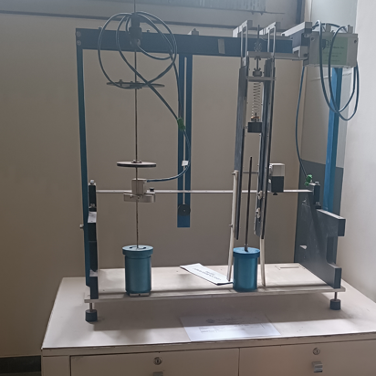 | Overview : The Theory of Machines course for Mechanical Engineering provides a comprehensive understanding and analysis of mechanisms for the specified type of motion in a machine. With the study of rigid bodies motions and forces for the transmission systems, machine kinematics and dynamics can be well understood.  In the lab, students typically have access to a variety of equipment and experimental setups that allow them to observe and manipulate different types of machines and mechanisms. This includes mechanisms like linkages, gears, cams, belts, and pulleys, among others.  Facilities and Equipment: Whirling of shaft + Motorized cam analysis, Universal governor, Motorised Gyrascope, Brake lining/ clutch friction test rig, Balancing of reciprocating masses , Universal vibration test rig, Generation of involute geartooth profile model, Epicyclic Gear Train eqipment, Cam Analysis equipment, Test rig for Belt Drive Equipment  Utilization: This course is for students from S.Y, T.Y Mechanical engineering and S.Y Manufacturing Engineering and Industrial Management.  Lab Incharge: Dr. Shivnanda Bhavikatti  Laboratory Area: 92 m²

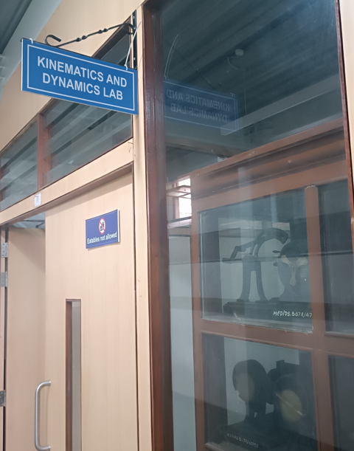 | 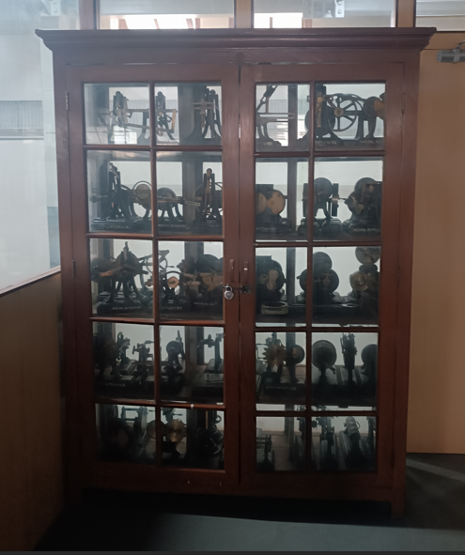
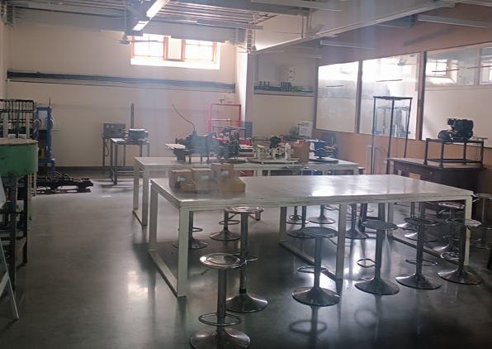
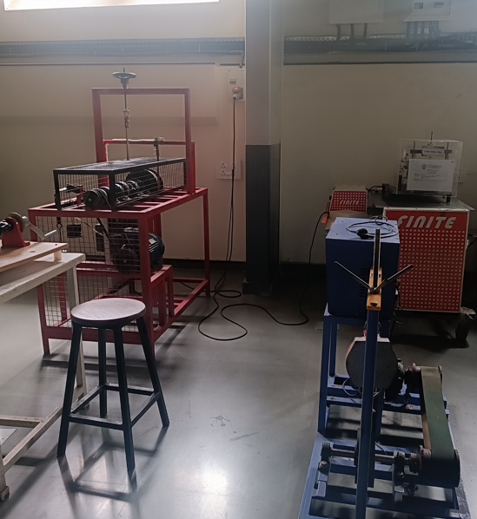 | 